22f-3441
Coal Activity
Exercise:
Question 1:
Call L2
Question 2:
a. pop ip ; Invalid instruction
b. jmp L5 ; Equivalent jump instruction
c. add sp, -2 ; Equivalent subtraction of 2 from SP
d. pop ax ; Equivalent pop instruction
e. add sp, 6 ; Equivalent addition of 6 to SP
mov ip, [ss:sp-6] ; Invalid instruction
Question 3:
section .text
global _start

_start:
; Example of calling the Fibonacci function with n=5
mov ax, 5
call fibonacci

; Result is now in AX

; Exit the program (assuming a syscall for exit in DOS)
mov ah, 4Ch ; DOS function for exit
int 21h ; make DOS syscall

fibonacci:
; Recursive Fibonacci function
; Input: AX contains the value of n
; Output: AX contains the Fibonacci number for n

; Base cases
cmp ax, 0
je fib_zero
cmp ax, 1
je fib_one

; Recursive case: fib(n) = fib(n-1) + fib(n-2)

; Save return address on the stack
push ax

; Calculate fib(n-1)
dec ax
call fibonacci
mov bx, ax ; Save result in bx

; Restore n and calculate fib(n-2)
pop ax
sub ax, 2
call fibonacci

; Add fib(n-1) and fib(n-2)
add ax, bx

; Return the result
ret

fib_zero:
; Base case: fib(0) = 0
mov ax, 0
ret

fib_one:
; Base case: fib(1) = 1
mov ax, 1
ret
Question 4:
section .text
global _start

_start:
mov ax, 5
call fibonacci_iterative

mov ah, 4Ch
int 21h

fibonacci_iterative:
cmp ax, 0
je fib_zero
cmp ax, 1
je fib_one

mov cx, ax
mov ax, 1
mov bx, 0

fibonacci_loop:
add ax, bx
mov bx, ax
dec cx
jg fibonacci_loop

ret

fib_zero:
mov ax, 0
ret

fib_one:
mov ax, 1
ret

Question 5:
section .text
global switch_stack

switch_stack:
pop es ; Pop new stack segment into ES register
pop sp ; Pop new stack offset into SP register
retf ; Return with far return, switching to the new stack
Question 6:
max_functions equ 8
function_set resw max_functions
functions_count resw 1

addtoset:
cmp word [functions_count], max_functions
jge addtoset_exit

mov bx, [functions_count]
mov [function_set + bx * 2], ax
inc [functions_count]

addtoset_exit:
ret

callset:
mov cx, [functions_count]
mov si, 0

callset_loop:
cmp si, cx
je callset_exit

call dword [function_set + si * 2]

inc si
jmp callset_loop

callset_exit:
ret
Question 7:

Question 8:
bit_array resb 0x80

myalloc:
mov cx, ax
mov dx, 0

alloc_loop:
cmp dx, 0x400
jge alloc_failed

mov si, dx
mov di, cx

find_zero_bits:
mov al, [bit_array + si / 8]
shr al, si % 8
jc skip_allocation

mov al, 1
shl al, si % 8
or [bit_array + si / 8], al

dec di
jz alloc_done

skip_allocation:
inc si
jmp find_zero_bits

alloc_done:
mov ax, dx
ret

alloc_failed:
mov ax, -1
ret

myfree:
mov si, ax
mov di, cx

free_loop:
cmp di, 0
jz free_done

mov al, 1
shl al, si % 8
not al
and [bit_array + si / 8], al

inc si
dec di
jmp free_loop

free_done:
ret
Question 9:
queues resw 16*32
queue_status resw 1

qcreate:
mov cx, 16
mov di, 0

find_free_queue:
test word [queue_status], 1 << di
jz found_free_queue

inc di
loop find_free_queue

mov ax, -1
ret

found_free_queue:
or [queue_status], 1 << di

mov si, 0
mov cx, 32
rep stosw

mov ax, di
ret

qdestroy:
test ax, ax
js qdestroy_exit

and [queue_status], not (1 << ax)

qdestroy_exit:
ret

qadd:
test ax, ax
js qadd_exit

imul si, ax, 32
mov dx, [queues + si]
mov cx, [queues + si + 2]

cmp dx, cx
je qadd_exit

mov [queues + si + cx * 2 + 4], bx
inc cx
mov [queues + si + 2], cx

mov si, 1
ret

qadd_exit:
mov si, 0
ret

qremove:
test ax, ax
js qremove_exit

imul si, ax, 32
mov dx, [queues + si]
mov cx, [queues + si + 2]

cmp dx, cx
je qremove_exit

mov bx, [queues + si + dx * 2 + 4]
inc dx
mov [queues + si], dx

mov si, 1
ret

qremove_exit:
mov si, 0
ret
EXAMPLE 5.5:
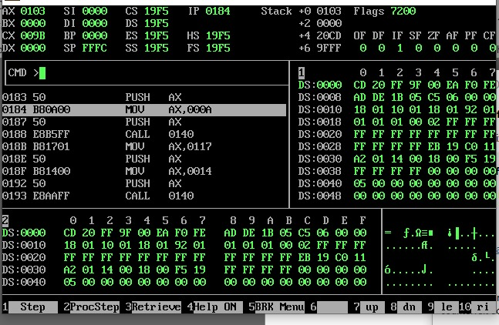
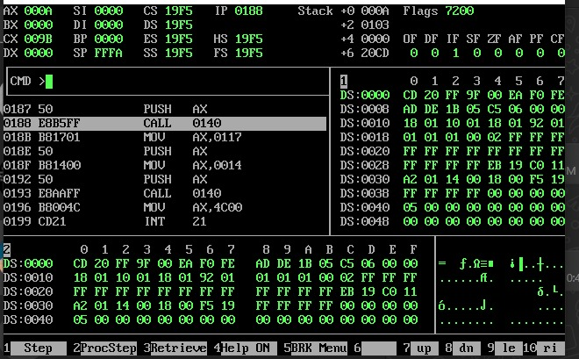
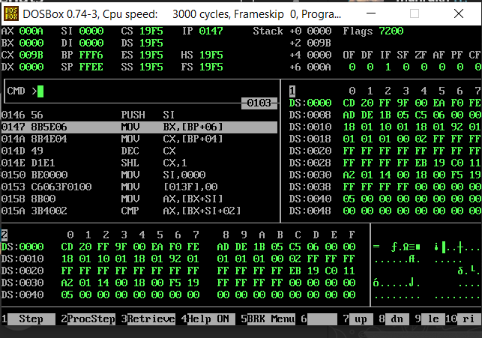
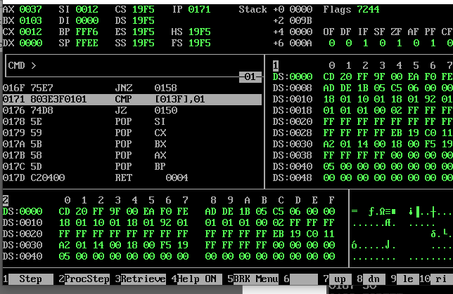
EXAMPLE 5.6:
